Chapter 3 homework

- Complete exercises
  - 3.4 - Skip b. For a, use box and dot plots. For c, use a histogram. For e, use a QQ-plot with a normal distribution and skip the correlation part. For g, also use Levene's test.
  - 3.8 - For a, use box and dot plots. For b, use a histogram of the residuals or semistudentized residuals. For d, use a QQ-plot with a normal distribution and skip the correlation part. For e, use the median of X instead of 69.
  - 3.27 - use examine.mod.simple() to examine the models in part a.
- Reproduce the Box-Cox transformation results for the example on p. 136. See the partial answers below for more on this problem.
- Examine tests from 2012
- Reproduce all examples in the notes

Partial answers:

3.4 Here is my code and the corresponding output.

> source("C:/chris/UNL/STAT870/Chapter3/examine.mod.simple.R")

> ############################################################################
> # NAME: Chris Bilder #
> # DATE: 7-21-06 #
> # PURPOSE: 3.4 in KNN #
> # #
> # NOTES: 1) #
> # #
> ############################################################################

> #Read in the data
> copier<-read.table(file = "C:\\chris\\UNL\\STAT870\\Instructor_CD\\Data
Sets\\Chapter 1 Data Sets\\CH01PR20.txt", header = FALSE,
col.names = c("minutes", "copiers"), sep = "")
> #Check first few observations
> head(copier)
minutes copiers
1 20 2
2 60 4
3 46 3
4 41 2
5 12 1
6 137 10

> ################################################################################
> # 3.4

> #Fit the simple linear regression model and save the results to mod.fit
> mod.fit<-lm(formula = minutes ~ copiers, data = copier)
> sum.fit<-summary(mod.fit)
> sum.fit

Call:
lm(formula = minutes ~ copiers, data = copier)

Residuals:
Min 1Q Median 3Q Max
-22.7723 -3.7371 0.3334 6.3334 15.4039

Coefficients:
Estimate Std. Error t value Pr(>|t|)
(Intercept) -0.5802 2.8039 -0.207 0.837
copiers 15.0352 0.4831 31.123 <2e-16 ***
---
Signif. codes: 0 '***' 0.001 '**' 0.01 '*' 0.05 '.' 0.1 ' ' 1

Residual standard error: 8.914 on 43 degrees of freedom
Multiple R-Squared: 0.9575, Adjusted R-squared: 0.9565
F-statistic: 968.7 on 1 and 43 DF, p-value: < 2.2e-16

> #Again, just because this function makes a student's life simpler,
> # you are still responsible for knowing all the code within it!
> save.it<-examine.mod.simple(mod.fit.obj = mod.fit, var.test = TRUE)
> save.it
$sum.data
Y X
Min. : 3.00 Min. : 1.000
1st Qu.: 36.00 1st Qu.: 2.000
Median : 74.00 Median : 5.000
Mean : 76.27 Mean : 5.111
3rd Qu.:111.00 3rd Qu.: 7.000
Max. :156.00 Max. :10.000

$semi.stud.resid
1 2 3 4 5 6 7 8 9 10 11 12 13
-1.06 0.05 0.17 1.29 -0.28 -1.43 -0.74 1.62 -1.17 0.28 1.04 0.70 0.38
14 15 16 17 18 19 20 21 22 23 24 25 26
-0.96 1.40 -2.21 0.04 1.27 -2.55 -0.29 -0.96 -0.41 0.49 -0.07 -0.08 0.82
27 28 29 30 31 32 33 34 35 36 37 38 39
-1.29 -0.18 0.71 0.71 0.37 1.73 -1.06 -0.17 -1.29 -0.29 1.28 -0.31 0.82
40 41 42 43 44 45
1.41 -0.42 0.51 -0.28 0.16 0.27

$levene
Levene's Test for Homogeneity of Variance
Df F value Pr(>F)
group 1 0.4744 0.4947
43

$bp

Breusch-Pagan test

data: Y ~ X
BP = 1.3147, df = 1, p-value = 0.2515
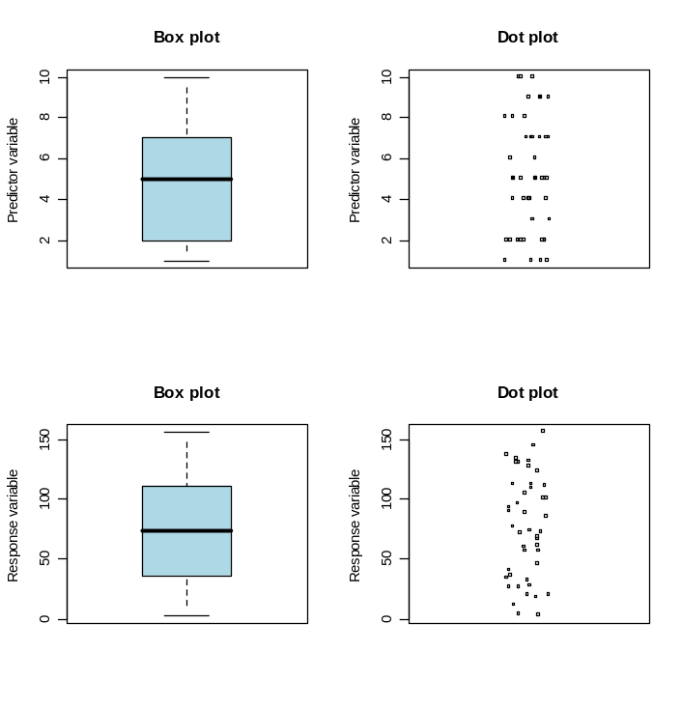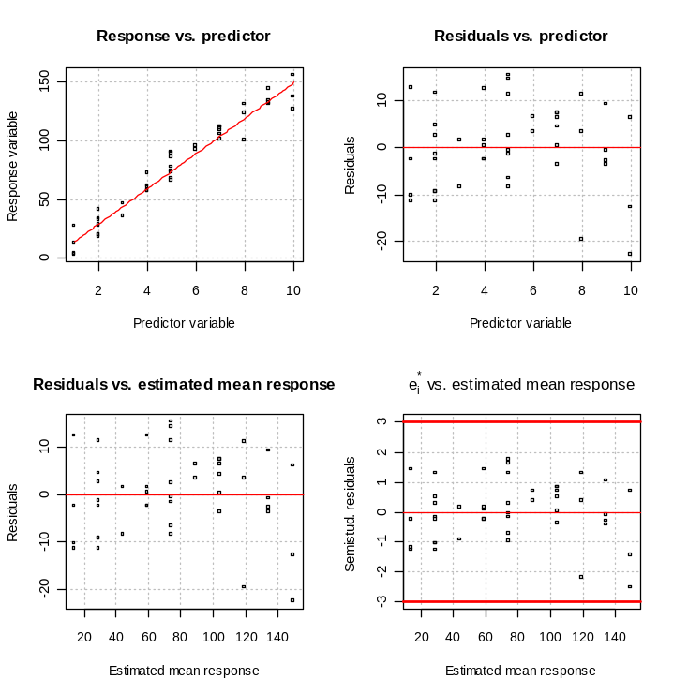

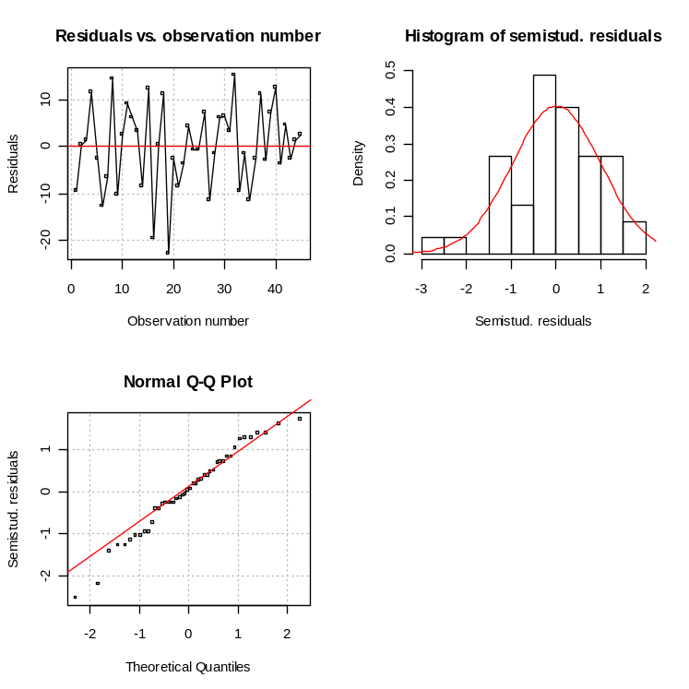

>################################################################################## >#3.4h

> copier2<-read.table(file = "C:\\chris\\UNL\\STAT870\\Instructor_CD\\Data
Sets\\Chapter 3 Data Sets\\CH03PR04.txt", header = FALSE,
col.names = c("minutes", "copiers", "age.copier",
"experience"), sep = "")
> head(copier2)
minutes copiers age.copier experience
1 20 2 20 4
2 60 4 19 5
3 46 3 27 4
4 41 2 32 1
5 12 1 24 4
6 137 10 26 4

> par(mfrow = c(1,2))
> plot(x = copier2$age.copier, y = mod.fit$residuals, xlab = "Age of copier
(months)", ylab = "Residual", main = "Residual vs. Copier age",
panel.first = grid(col = "gray", lty = "dotted"))
> abline(h = 0, col = "red")
> abline(lm(formula = mod.fit$residuals ~ copier2$age.copier), col = "darkgreen")
#Quick way to get a line on plot to show relationship

> plot(x = copier2$experience, y = mod.fit$residuals, xlab = "Experience of
service person (years)", ylab = "Residual", main = "Residual vs.
Experience", panel.first = grid(col = "gray", lty = "dotted"))
> abline(h = 0, col = "red")
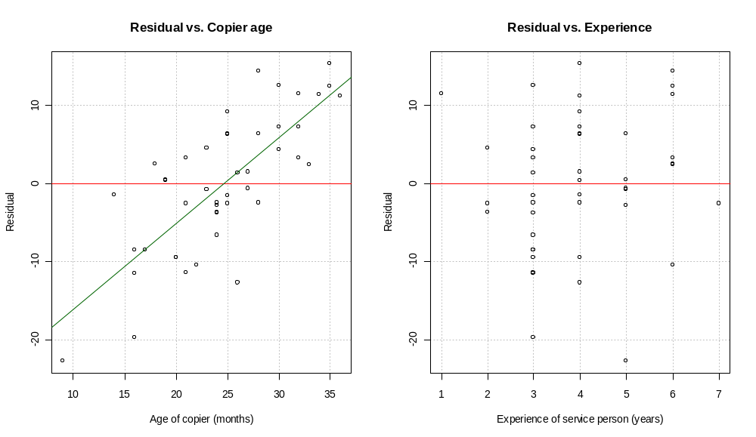

> mod.fit2<-lm(formula = minutes ~ copiers + age.copier, data = copier2)
> summary(mod.fit2)

Call:
lm(formula = minutes ~ copiers + age.copier, data = copier2)

Residuals:
Min 1Q Median 3Q Max
-13.4815 -3.2212 -0.5019 3.9245 10.6721

Coefficients:
Estimate Std. Error t value Pr(>|t|)
(Intercept) -27.0292 3.8787 -6.969 1.61e-08 ***
copiers 14.8734 0.3148 47.242 < 2e-16 ***
age.copier 1.1068 0.1433 7.726 1.36e-09 ***
---
Signif. codes: 0 '***' 0.001 '**' 0.01 '*' 0.05 '.' 0.1 ' ' 1

Residual standard error: 5.796 on 42 degrees of freedom
Multiple R-Squared: 0.9824, Adjusted R-squared: 0.9816
F-statistic: 1175 on 2 and 42 DF, p-value: < 2.2e-16

Overall, I do not see problems with the model, except perhaps normality and another predictor variable would be helpful. Answer a.-h. of the problem on your own. Notice how these parts are basically the same as the 7 items given in the Section 3.11 notes:

- Diagnostics for predictor and response variable
- Linearity of the regression model
- Constant error variance
- Independence of ε_{i}
- Outliers
- Normality of ε_{i}
- Additional independent variables

On a test, I may ask you to comment on each of these items.

Here are some additional comments about part h. There is a linear pattern in the residual vs. age of the copier (X₂) plot. To help you see this, I used a simple way to put a regression line on the plot. Also, I fit a multiple linear regression model to the data using the number of copiers and the age of the copiers as the predictor variables. Since we have not formally talked about multiple linear regression yet, you are not responsible for the multiple linear regression part of the code. However, using what you learned from Chapter 2, you are correct in assuming the p-value of 1.36e-09 is used to perform a hypothesis test to determine if the age of the copiers has a linear relationship with minutes. Since the p-value is small, we can see there is a relationship. This provides further justification for why looking for a pattern in a plot like residual vs. age of the copiers is helpful.

For part e, KNN’s answer key says “conclude error variance constant.” A better conclusion would be “there is not sufficient evidence against constant error variance.”

3.8 Do on your own. I found some possible normality problems on the tail of the distribution and one semistudentized residual close to the border (probably do not need to worry about).

3.27 Do on your own. Note that you will find #47 and #112 to be outliers. These observations have unusual Y values for their corresponding X values. Here are some ways to exclude them for part b:

mod.fit.infection<-lm(formula = stay ~ infection, data = senic, subset = c(1:46,
48:111, 113))

mod.fit.xray<-lm(formula = stay ~ xray, data = senic[-c(47,112),])

Removing observations from a data set should only occur when there is VERY GOOD justification for it! Just because an observation is an outlier or influential does NOT mean it should automatically be removed from the data set!!!!!!!!!!!!!!!!!!!!!!!!!!!!!!!!!!!! KNN are just trying to demonstrate what an outlier means for this problem.

If we knew more about the data set, we may be able to determine that these Y values were data entry errors. If they were, we could correct them (or remove the observation if we could not correct them). Also, if these observations had something in common (say, a particular disease), we could conclude that the model does not fit well for this particular disease. A way to fix this problem would be to include an additional variable in the model (multiple linear regression model) that denotes the disease or to remove the observations. When removing all observations for this disease, we would be making our population of inference smaller (people who do not have the disease). Overall, until we get to Chapter 10, our options are limited. We will go into more detail at that time. ☺

Answer key:
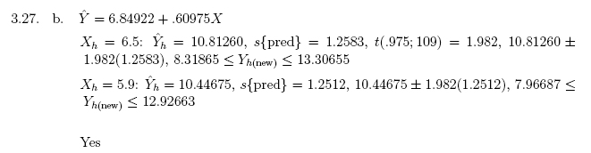

Example from p. 136 – Below is part of my code and output:

> plasma<-read.table(file = "C:\\chris\\UNL\\STAT870\\Instructor_CD\\Data
Sets\\Chapter 3 Data Sets\\CH03TA08.txt",
header = FALSE, col.names = c("age", "plasma.level",
"log10.plasma"), sep = "")
> #Check first few observations
> head(plasma)
age plasma.level log10.plasma
1 0 13.44 1.1284
2 0 12.84 1.1086
3 0 11.91 1.0759
4 0 20.09 1.3030
5 0 15.60 1.1931
6 1 10.11 1.0048

> mod.fit<-lm(formula = plasma.level ~ age, data = plasma)
> summary(mod.fit)

Call:
lm(formula = plasma.level ~ age, data = plasma)

Residuals:
Min 1Q Median 3Q Max
-2.7032 -1.0132 -0.1112 0.7188 6.6148

Coefficients:
Estimate Std. Error t value Pr(>|t|)
(Intercept) 13.4752 0.6379 21.126 < 2e-16 ***
age -2.1820 0.2604 -8.379 1.92e-08 ***
---
Signif. codes: 0 '***' 0.001 '**' 0.01 '*' 0.05 '.' 0.1 ' ' 1

Residual standard error: 1.841 on 23 degrees of freedom
Multiple R-Squared: 0.7532, Adjusted R-squared: 0.7425
F-statistic: 70.21 on 1 and 23 DF, p-value: 1.92e-08

> mod.fit2<-lm(formula = log(plasma.level, base=10) ~ age, data = plasma)
> summary(mod.fit2)

Call:
lm(formula = log(plasma.level, base = 10) ~ age, data = plasma)

Residuals:
Min 1Q Median 3Q Max
-0.11701 -0.03538 0.00262 0.02790 0.16816

Coefficients:
Estimate Std. Error t value Pr(>|t|)
(Intercept) 1.134819 0.021642 52.44 < 2e-16 ***
age -0.102283 0.008835 -11.58 4.51e-11 ***
---
Signif. codes: 0 '***' 0.001 '**' 0.01 '*' 0.05 '.' 0.1 ' ' 1

Residual standard error: 0.06247 on 23 degrees of freedom
Multiple R-Squared: 0.8535, Adjusted R-squared: 0.8472
F-statistic: 134 on 1 and 23 DF, p-value: 4.509e-11

> #Not that serious of a nonconstant variance problem indicated by plots (one
observation)??? Notice that Levene’s Test is marginally significant.
> save.it<-examine.mod.simple(mod.fit.obj = mod.fit, const.var.test = TRUE,
boxcox.find = TRUE)
> save.it
$sum.data
Y X
Min. : 4.860 Min. :0
1st Qu.: 6.230 1st Qu.:1
Median : 8.650 Median :2
Mean : 9.111 Mean :2
3rd Qu.:10.280 3rd Qu.:3
Max. :20.090 Max. :4

$semi.stud.resid
1 2 3 4 5 6 7 8 9 10 11 12 13
-0.02 -0.34 -0.85 3.59 1.15 -0.64 0.05 -0.55 -1.27 -1.47 0.39 -0.06 -0.25
14 15 16 17 18 19 20 21 22 23 24 25
-0.68 -0.13 0.55 -0.50 -0.97 -0.02 -0.09 0.06 0.19 0.50 0.54 0.81

$levene
Levene's Test for Homogeneity of Variance
Df F value Pr(>F)
group 1 2.8573 0.1045
23

$bp
Breusch-Pagan test

data: Y ~ X
BP = 11.1063, df = 1, p-value = 0.0008604

$lambda.hat
[1] -0.5

See the plots on your own. The residuals vs. predicted value plot is showing nonconstant variance only for the far right group of points. This may not be enough evidence for a transformation. Note that the points do not always have to be in a funnel shape. In this example, there are multiple observations at the same X values. To determine if there is nonconstant variance, look to see if some groups have more variability with respect to the y-axis than others.

The Box-Cox transformation estimated λ is -0.5. Notice 0 is in the interval suggesting a natural log transformation may be acceptable as well.

> mod.fit3<-lm(formula = plasma.level^save.it$lambda.hat ~ age, data = plasma)
> summary(mod.fit3)

Call:
lm(formula = plasma$plasma.level^save.it$lambda.hat ~ plasma$age)

Residuals:
Min 1Q Median 3Q Max
-0.0085510 -0.0026656 0.0001644 0.0020889 0.0126639

Coefficients:
Estimate Std. Error t value Pr(>|t|)
(Intercept) 1.0815177 0.0016060 673.43 < 2e-16 ***
plasma$age -0.0075430 0.0006556 -11.51 5.1e-11 ***
---
Signif. codes: 0 '***' 0.001 '**' 0.01 '*' 0.05 '.' 0.1 ' ' 1

Residual standard error: 0.004636 on 23 degrees of freedom
Multiple R-Squared: 0.852, Adjusted R-squared: 0.8455
F-statistic: 132.4 on 1 and 23 DF, p-value: 5.1e-11

> #Notice how large the p-values are for the constant variance tests next
> examine.mod.simple(mod.fit.obj = mod.fit3, const.var.test = TRUE)
$sum.data
Y X
Min. :1.049 Min. :0
1st Qu.:1.056 1st Qu.:1
Median :1.067 Median :2
Mean :1.066 Mean :2
3rd Qu.:1.072 3rd Qu.:3
Max. :1.094 Max. :4

$semi.stud.resid
1 2 3 4 5 6 7 8 9 10 11 12 13
-0.10 -0.42 -0.94 2.73 0.95 -0.45 0.37 -0.34 -1.29 -1.58 0.98 0.37 0.09
14 15 16 17 18 19 20 21 22 23 24 25
-0.57 0.28 1.13 -0.78 -1.84 0.17 0.04 -0.60 -0.27 0.45 0.55 1.09

$levene
Levene's Test for Homogeneity of Variance
Df F value Pr(>F)
group 1 0.7058 0.4095
23

$bp

Breusch-Pagan test

data: Y ~ X
BP = 2.2846, df = 1, p-value = 0.1307

See the plots on your own. Overall, it looks like this transformation improves upon the nonconstant variance problem.

